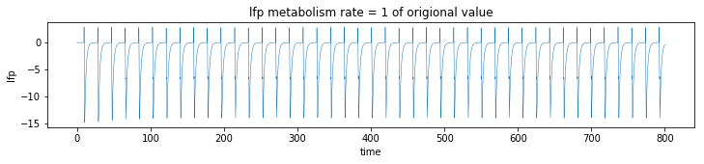

LFP with 2 cells, single AMPA current, no GABA Looks right!

Metabolism rate full value 2 cells , without GABA:

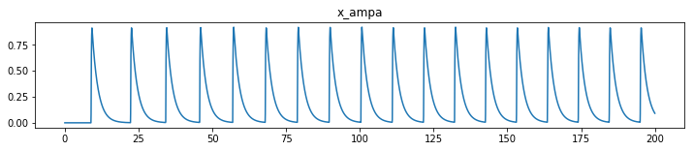

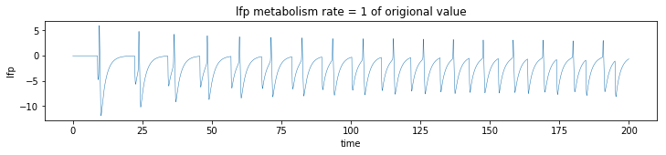

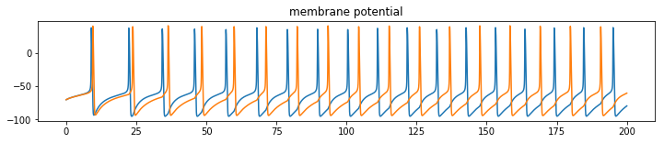

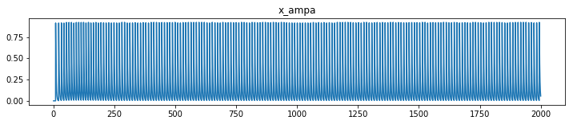

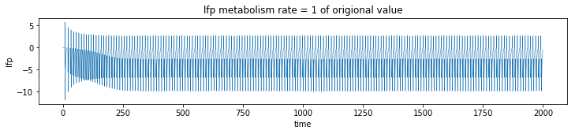

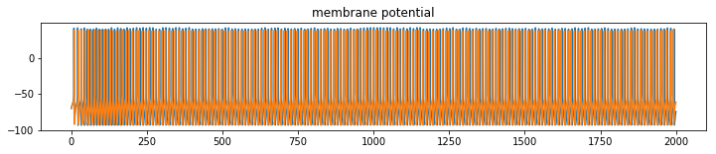  
Metabolism rate, full value, with GABA

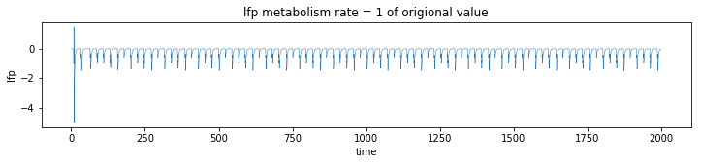

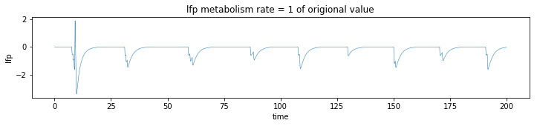

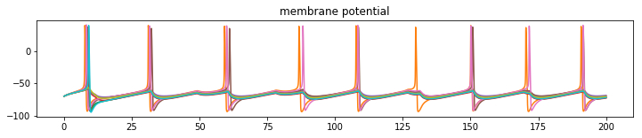

Not many spikin?

* Better this time

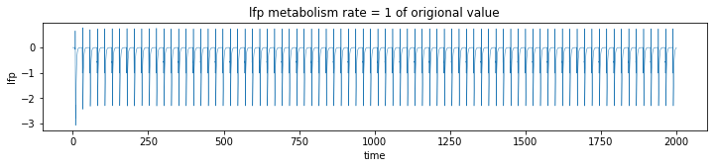

.3 of oritional :

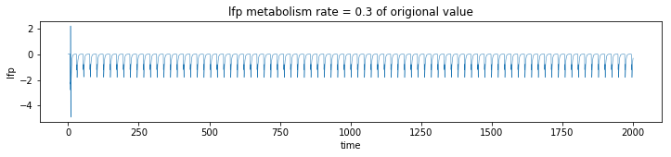

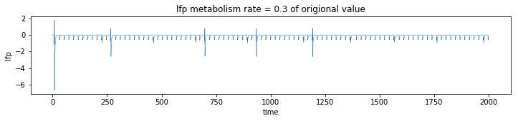

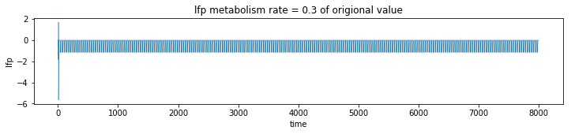

I think they did filter LFP to get smoothness?